C Language Fundamental)

**• Display This Information using printf**

1. Your Name
2. Your Birth date
3. Your Age
4. Your Address

#include <stdio.h>

int main(){

printf("Divyesh Chauhan\n");

printf("age-21\n");

printf("Birthday-09,05,2002\n");

printf("From-Dhandhuka");

return 0;

}

**• Write a program to make Simple calculator (to make addition, subtraction, multiplication, division and modulo)**

**#include<stdio.h>**

**int main()**

**{**

**int a,b,c,result;**

**char ch;**

**printf("enter (+,-,*,/) :");**

**scanf("%c",&ch);**

**fflush(stdin);**

**printf("enter your no. \n:");**

**scanf("%d",&a);**

**printf("enter your no.\n");**

**scanf("%d",&b);**

**switch (ch){**

**case'+':**

**c=a+b;**

**printf("enter %d",c);**

**break;**

**case'-':**

**c=a-b;**

**printf("enter %d",c);**

**break;**

**case'*':**

**c=a*b;**

**printf("enter %d",c);**

**break;**

**case'/':**

**c=a/b;**

**printf("enter %d",c);**

**break;**

**printf("result= %d",result);**

**}**

**return 0;**

**}**

**• WAP to find area of circle, rectangle and triangle**

**#include<stdio.h>**

**#define PI 3.147**

**void main()**

**{**

**float radius, length, breadth;**

**float base, height, area;**

**int choice;**

**printf("Enter\n");**

**printf("1. To find area of triangle\n");**

**printf("2. To find area of circle\n3. To find area of rectangle\n");**

**scanf("%d",&choice);**

**switch(choice)**

**{**

**case 1:**

**printf("Enter base and height of a triangle\n");**

**scanf("%f %f", &base, &height);**

**area = (1.0/2) * base * height;**

**printf("Area of Triangle:\t%f\n", area);**

**break;**

**case 2:**

**printf("Enter the radius of a Circle\n");**

**scanf("%f", &radius);**

**area = PI * radius * radius;**

**printf("Area of Circle:\t%f\n", area);**

**break;**

**case 3:**

**printf("Enter the length and breadth of a Rectangle\n");**

**scanf("%f %f", &length, &breadth);**

**area = length * breadth;**

**printf("Area of Rectangle:\t%f\n", area);**

**break;**

**default:**

**printf("Invalid Choice\n");**

**}**

**}**

**• WAP to find simple interest**

#include<stdio.h>

**int** main()

    {

**float** P , R , T , SI ;

       P =34000; R =30;  T = 5;

        SI  = (P*R*T)/100;

        printf("\n\n Simple Interest is : %f", SI);

**return** (0);

}

**• WAP to check if the given year is a leap year or not.**

**#include <stdio.h>**

**int main()**

**{**

**int year;**

**printf("Enter a year to check if it is a leap year\n");**

**scanf("%d", &year);**

**if ( year%400 == 0)**

**printf("%d is a leap year.\n", year);**

**else if ( year%100 == 0)**

**printf("%d is not a leap year.\n", year);**

**else if ( year%4 == 0 )**

**printf("%d is a leap year.\n", year);**

**else**

**printf("%d is not a leap year.\n", year);**

**return 0;**

**}**

**• WAP to convert years into days and days into years**

#include<stdio.h>

**int** main()

                   { **int** days, years;

                   days= 543;

                   years=  days / 365;

                   printf("\n\n Number of years is : %d",years);

**return** (0);

    }

C Language Programing

**• WAP to make simple calculator (operation include Addition, Subtraction, Multiplication, Division, modulo)**

**#include<stdio.h>**

**int main()**

**{**

**int a,b,c,result;**

**char ch;**

**printf("enter (+,-,*,/) :");**

**scanf("%c",&ch);**

**fflush(stdin);**

**printf("enter your no. \n:");**

**scanf("%d",&a);**

**printf("enter your no.\n");**

**scanf("%d",&b);**

**switch (ch){**

**case'+':**

**c=a+b;**

**printf("enter %d",c);**

**break;**

**case'-':**

**c=a-b;**

**printf("enter %d",c);**

**break;**

**case'*':**

**c=a*b;**

**printf("enter %d",c);**

**break;**

**case'/':**

**c=a/b;**

**printf("enter %d",c);**

**break;**

**printf("result= %d",result);**

**}**

**return 0;**

**}**

• WAP to swap two numbers without using third variable

1. #include<stdio.h>
2. **int** main()
3. {
4. **int** a=10, b=20;
5. printf("Before swap a=%d b=%d",a,b);
6. a=a+b;//a=30 (10+20)
7. b=a-b;//b=10 (30-20)
8. a=a-b;//a=20 (30-10)
9. printf("\nAfter swap a=%d b=%d",a,b);
10. **return** 0;
11. }

**• WAP to find number is even or odd using ternary operator**

#include<stdio.h>

int main() {

int n;

printf("Enter any number:\n");

scanf("%d",&n);

(n%2) ? printf("%d is odd number",n) : printf("%d is even number",n);

return 0;

}

**• WAP to show**

1. **Monday to Sunday using switch case**

#include<stdio.h>

main()

{

int number;

printf("Enter your choise");

scanf("%d",&number);

switch(number){

case 1:

printf("Monday");

break;

case 2:

printf("Tuseday");

break;

case 3:

printf("Wednesday");

break;

case 4:

printf("Thursday");

break;

case 5:

printf("Friday");

break;

case 6:

printf("Saturday");

break;

case 7:

printf("Sunday");

break;

}

}

1. **Vowel or Consonant using switch case**

#include<stdio.h>

main()

{

char cha;

printf("enter alphabat :");

scanf("%c",&cha);

switch(cha){

case'a':

printf("vowel");

break;

case'e':

printf("vowel");

break;

case'i':

printf("vowel");

break;

case'o':

printf("vowel");

break;

case'u':

printf("vowel");

break;

case'O':

printf("vowel");

break;

case'A':

printf("vowel");

break;

case'I':

printf("vowel");

break;

case'E':

printf("vowel");

break;

default:

printf("cost");

}

return 0;

}

**• Looping programs:**

1. **WAP to print 972 to 897 using for loop**

*// Print numbers from 1 to 10*

#include <stdio.h>

int main() {

int i;

for (i = 1; i < 11; ++i)

{

printf("%d ", i);

}

return 0;

}

1. **WAP to take 10 no. Input from user and find out …**

#include<stdio.h>

void main() {

int i; //Variable definition

printf("The first 10 natural numbers are:\n ");

for (i = 1; i <= 10; i++) //Iteration 10 times

{

printf("%d \t", i); //Print the number.

}

}

1. **How many Even numbers are there**

There are infinitely many even numbers. Any number of the form 2×k is even, where k can be any integer number, thus we have infinitely many possible choices for k.

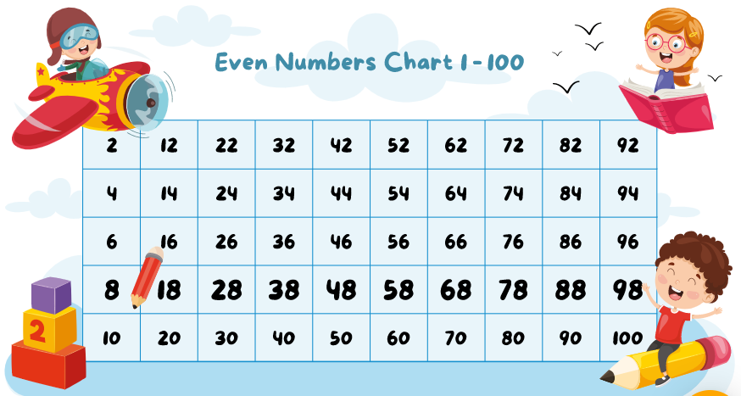

**4. How many odd numbers are there**

List of Odd Numbers. There are 25 odd numbers from 1 to 50 while there are 50 in between 1 and 100. In case of numbers from 1 to 1000, there are 500 odd numbers and 500 even numbers.

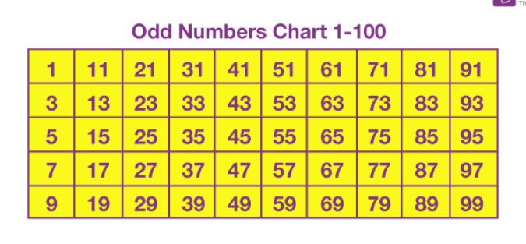

**5. Sum of even numbers**

1. #include <stdio.h>
2. **int** main()
3. {
4. **int** i, n, sum=0;
5. printf("Enter any number: ");
6. scanf("%d", &n);
7. **for**(i=2; i<=n; i+=2)
8. {
9. sum += i;
10. }
11. printf("Sum of all even numbers from 1 to %d: %d", n, sum);
12. **return** 0;

}

**6. Sum of odd numbers WAP to print table up to given numbers**

#**include** <stdio.h>

**int** main()

{

**int** i, n, sum=0;

/* Input range to find sum of odd numbers */

printf("Enter upper limit: ");

scanf("%d", &n);

/* Find the sum of all odd number */

**for**(i=1; i<=n; i+=2)

{

sum += i;

}

printf("Sum of odd numbers = %d", sum);

**return** 0;

}

**• WAP to print factorial of given number**

1. #include<stdio.h>
2. **int** main()
3. {
4. **int** i,fact=1,number;
5. printf("Enter a number: ");
6. scanf("%d",&number);
7. **for**(i=1;i<=number;i++){
8. fact=fact*i;
9. }
10. printf("Factorial of %d is: %d",number,fact);
11. **return** 0;
12. }

**• WAP to print Fibonacci series up to given numbers**

**#include <stdio.h>**

**int main() {**

**int i, n;**

**// initialize first and second terms**

**int t1 = 0, t2 = 1;**

**// initialize the next term (3rd term)**

**int nextTerm = t1 + t2;**

**// get no. of terms from user**

**printf("Enter the number of terms: ");**

**scanf("%d", &n);**

**// print the first two terms t1 and t2**

**printf("Fibonacci Series: %d, %d, ", t1, t2);**

**// print 3rd to nth terms**

**for (i = 3; i <= n; ++i) {**

**printf("%d, ", nextTerm);**

**t1 = t2;**

**t2 = nextTerm;**

**nextTerm = t1 + t2;**

**}**

**return 0;**

**}**

* **WAP to print number in reverse order e.g.: number = 64728 ---> reverse = 82746**

#include <stdio.h>

int main() {

int n, reverse = 0, remainder;

printf("Enter an integer: ");

scanf("%d", &n);

while (n != 0) {

remainder = n % 10;

reverse = reverse * 10 + remainder;

n /= 10;

}

printf("Reversed number = %d", reverse);

return 0;

}

* **Write a program to find out the max from given number (E.g., No: -1562 Max number is 6)**

#include<stdio.h>  
void main()  
{  
      int a[5],i,max=0,min=0;  
      clrscr();  
      printf("Enter Five Value :");  
      for(i=0;i<=4;i++)  
          {  
               scanf("%d",&a[i]);  
          }  
      for(i=0;i<=4;i++)  
          {  
              if(a[i]>max)  
               {  
                    max=a[i];   
                     
               }  
              else  
               {  
                    min=a[i];  
                     
               }  
                     
           }  
                    printf("Minium is : %d\n",min);  
                    printf("Maximum is : %d\n",max);  
                    getch();  
}

**• Write a program make a summation of given number (E.g., 1523 Ans: -11)**

**#include <stdio.h>**

**int main()**

**{**

**int num, sum=0;**

**/* Input a number from user */**

**printf("Enter any number to find sum of its digit: ");**

**scanf("%d", &num);**

**/* Repeat till num becomes 0 */**

**while(num!=0)**

**{**

**/* Find last digit of num and add to sum */**

**sum += num % 10;**

**/* Remove last digit from num */**

**num = num / 10;**

**}**

**printf("Sum of digits = %d", sum);**

**return 0;**

**}**

* **Write a program you have to make a summation of first and last Digit. (E.g., 1234 Ans: -5)**

**int main()**

**{**

**int num, sum=0, firstDigit, lastDigit;**

**/* Input a number from user */**

**printf("Enter any number to find sum of first and last digit: ");**

**scanf("%d", &num);**

**/* Find last digit to sum */**

**lastDigit = num % 10**

**/* Copy num to first digit */**

**firstDigit = num;**

**/* Find the first digit by dividing num by 10 until first digit is left*/**

**while(num >= 10)**

**{**

**num = num / 10;**

**}**

**firstDigit = num;**

**/* Find sum of first and last digit*/**

**sum = firstDigit + lastDigit;**

**printf("Sum of first and last digit = %d", sum);**

**return 0;**

**}**

**Patterns:**

**#include <stdio.h>**

**void main()**

**{**

**int i, j, rows, k = 0;**

**printf (" Enter a number to define the rows: \n");**

**scanf ("%d", &rows);**

**for ( i =1; i <= rows; i++)**

**{**

**for ( j = 1; j <= rows - i; j++)**

**{**

**printf (" ");**

**}**

**// use for loop where k is less than equal to (2 * i -1)**

**for ( k = 1; k <= ( 2 * i - 1); k++)**

**{**

**printf ("* "); // print the Star**

**}**

**printf ("\n");**

**}**

**} \***

**\* * \***

**\* * * * \***

**\* * * * * * \***

**\* * * * * * * * \***

**#include <stdio.h>**

**void main()**

**{**

**int num, i, j, m = 1; // declare local variables**

**printf (" Enter the number to define the columns: \n");**

**scanf ("%d", & num);**

**for (i = 1; i <= num; i++)**

**{**

**for (j = 1; j <= i; j++)**

**{**

**printf( "* ");**

**}**

**printf("\n");**

**}**

**for (i = num-1; i >= 1; i--)**

**{**

**for (j = 1; j <= i; j++)**

**{**

**printf ("* ");**

**}**

**printf("\n");**

**}**

**}**

**\***

**\* \***

**\* * \***

**\* * * \***

**\* * * * \***

**\* * * * * \***

**\* * * * \***

**\* * * \***

**\* * \***

**\* \***

**\***

**#include <stdio.h>**

**int main()**

**{**

**int i,j,num=1;**

**for( i=1;i<=5;i++)**

**{**

**for( j=1;j<=i;j++)**

**{**

**printf("%d",num);**

**num++;**

**}**

**printf("\n");**

**}**

**return 0;**

**}**

**1**

**2 3**

**4 5 6**

**7 8 9 10**

**11 12 13 14 15**

**#include <stdio.h>**

**int main()**

**{**

**int i,j,a='a';**

**for( i=1;i<=5;i++)**

**{**

**for( j=1;j<=i;j++)**

**{**

**printf("%c",a++);**

**}**

**printf("\n");**

**}**

**return 0;**

**}**

**a**

**b c**

**d e f**

**g h I j**

**k l m n o**

**#include<stdio.h>**

**void main()**

**{**

**int i,j;**

**for(i=1;i<=5;i++)**

**{**

**for(j=1;j<=i;j++)**

**{**

**printf("%c",j+64);**

**}**

**printf("\n");**

**}**

**}**

**A**

**A B C**

**A B C D**

**A B C D E**

**#include<stdio.h>**

**void main()**

**{**

**int i,j;**

**for(i=1;i<=5;i++)**

**{**

**for(j=1;j<=i;j++)**

**{**

**printf("%d",j%2);**

**}**

**printf("\n");**

**}**

**}**

**1**

**1 0**

**1 0 1**

**1 0 1 0**

**1 0 1 0 1**